6/15/2024

Group 2

Group Sprint Deliveries

Sprint 0 – Sprint 5

Contents

Introduction 2

Sprint 0 2

Work done 2

Documentation 3

Project Plan 3

User stories 3

Figma prototypes 4

System logs ERD 5

Next sprint 6

Sprint 1 6

Work done 6

Documentation 7

Research plan 7

GitHub issues 7

Minutes & Retrospective 8

Azure 8

Local environment 8

Progress of issues 8

Next sprint 9

Sprint 2 10

Work done 10

Documentation 10

GitHub issues 10

Minutes & Retrospective 11

Ethical report 11

Progress of issues 11

Next sprint 11

Sprint 3 11

Work done 11

Documentation 12

GitHub issues 12

Minutes & Retrospective 12

Progress of issues 13

Next sprint 13

Sprint 4 13

Work done 13

Documentation 13

GitHub issues 14

Progress of issues 15

Next sprint 16

Sprint 5 16

Work done 16

Progress of issues 16

Merging progress/Repository transfer 17

Updating documentation 18

Recording a demo video 18

Presentation 20th June at 's-Hertogenbosch 19

# Introduction

This document is a compilation of all of the sprints that were carried out for the group project of the Sem. 6 Advanced software by group 2 working on the LLM Insights project.

The sprints summarize the progress made through the Fontys defined sprints and are handed to Fontys for bookkeeping. Keep in mind that since Fontys and CY2 sprints do not match, they can contain mid-work sprint. They are all submitted individually in Canvas’ respective assignments.

All of the latest documents can also be found in the MS Teams group.

https://teams.microsoft.com/_#/school/FileBrowserTabApp/General?threadId=19:gROJe5pCOxpc9ttA5cJXcO3BSZdZ-wUvnhoOluaCj781@thread.tacv2&ctx=channel

All of the user stories/issues that the team has worked on can also be found on GitHub https://github.com/orgs/CY2Project/projects/1/views/1

# Sprint 0

## Work done

This chapter has the purpose of briefly presenting the progress made during the sprint.

During Sprint 0, necessary arrangements have been made in order to establish the scope of the project and shaping the future work of the semester. Mainly, the first sprint focused around documentation and understanding the project.

## Documentation

The documents created during Sprint 0 revolve around future planning. Thus, the following have been created:

* Project Plan
* User Stories
* Figma Prototypes
* System logs ERD

## Project Plan

The project plan establishes the context, scope and future work of the project. The delivery of the plan can be found [in canvas.](https://fhict.instructure.com/courses/13669/assignments/234579?module_item_id=1060261)

## User stories

The user stories document contains the defined future work that will be achieved during the following sprints.

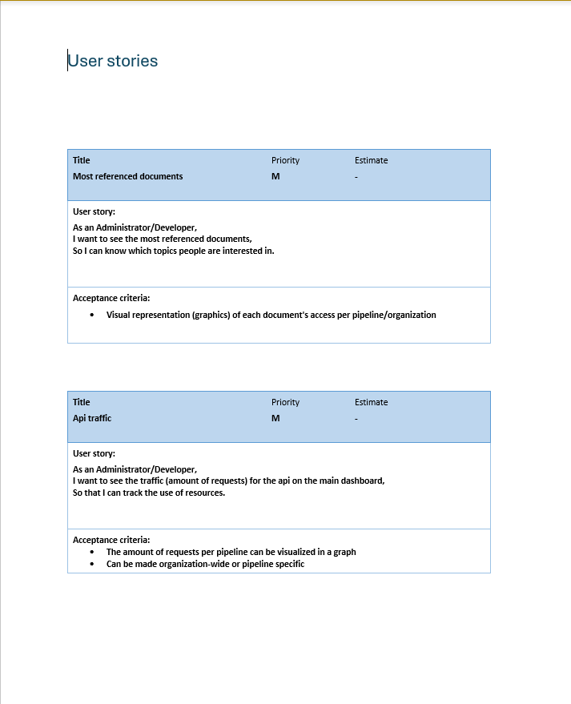

## Figma prototypes

The created figma prototypes offer the stakeholder as well as the group a point of reference regarding the end-goal of the project

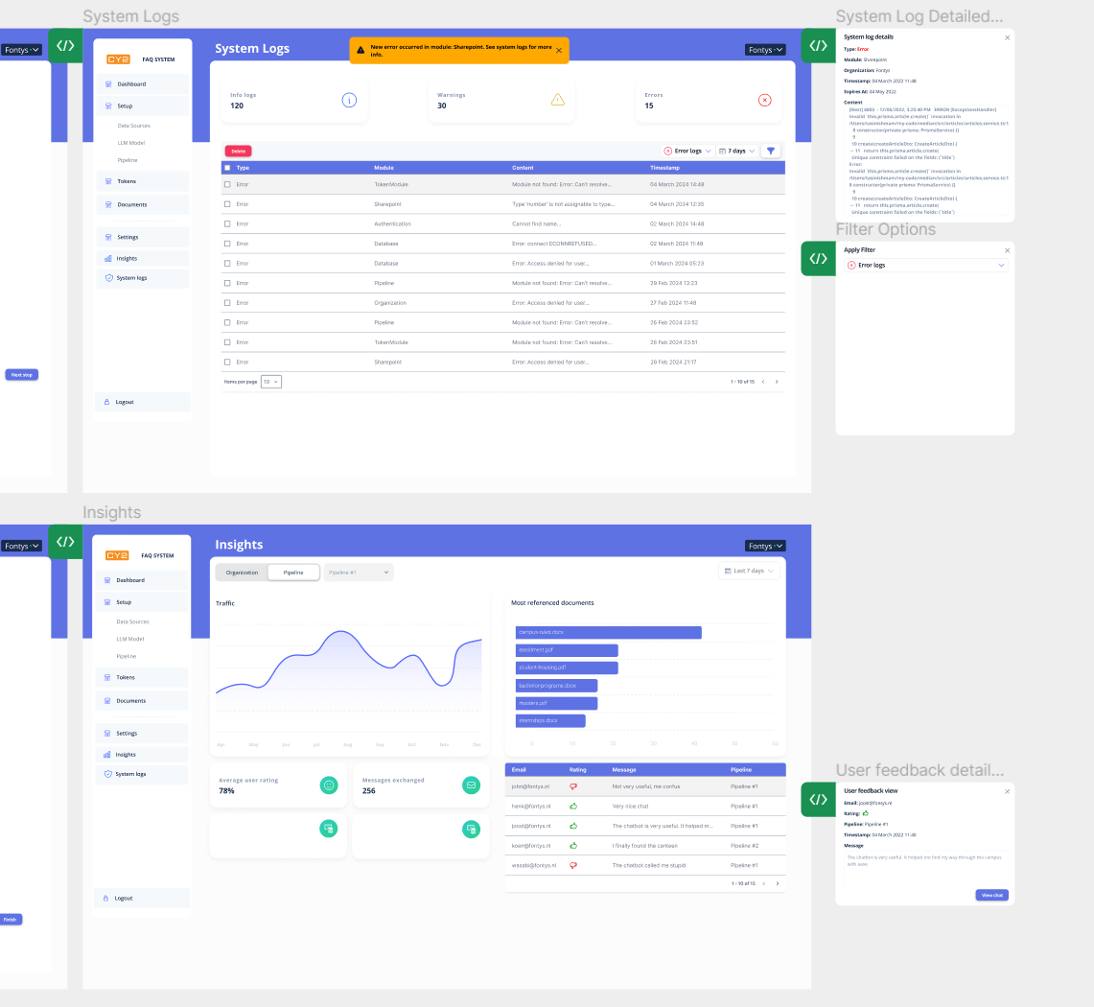

## System logs ERD

A quick ERD mockup to get a general idea of future work

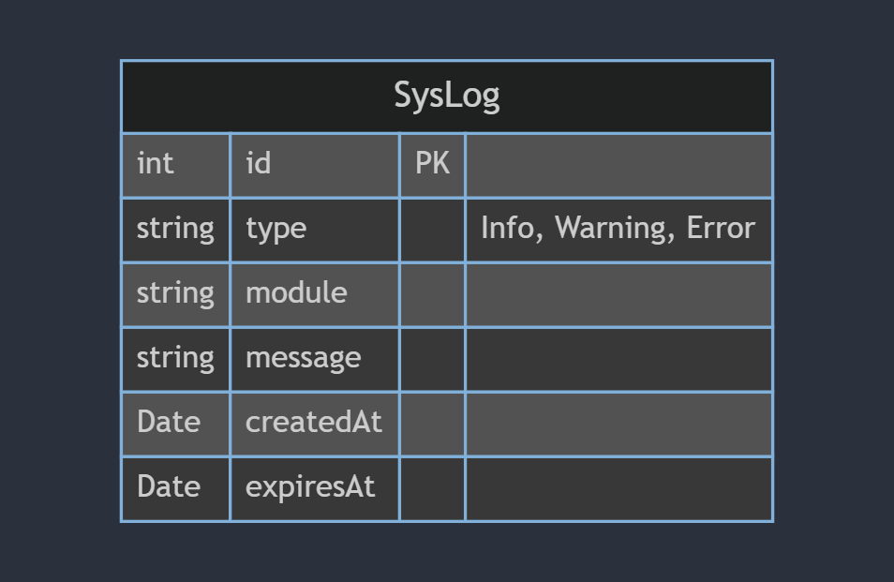

## Next sprint

Next sprint the group is going to focus on the following activities:

* Exploring the project source code
* Starting to develop a walking skeleton of the system logs and llm logs
* Initial frontend code

The full backlog can be found in MS Teams

# Sprint 1

## Work done

This chapter briefly presents the progress made during the sprint.

During sprint 1, a lot of investigative work was done to try and assess the state of the project that the previous group left behind. There was also a lot of setuplike Azure environment, GitHub and local development environment

## Documentation

The documents created during Sprint 1 are mainly used for internal reference, along with the research plan that is handed in at Canvas

* Research plan
* GitHub issues
* Meeting minutes
* Sprint retrospective

## Research plan

The research plan establishes the research questions for the project, along with how they are going to be answered. The delivery of the plan can be found [in canvas.](https://fhict.instructure.com/courses/13669/assignments/234576?module_item_id=1060290)

## GitHub issues

This sprint we needed to lay down the user stories in GitHub issues, as well as create the remaining sprints and map out tasks. Below can be seen a screenshot of the issue board

## Minutes & Retrospective

Documents used for internal references in the group. They can be found in [teams](https://teams.microsoft.com/l/channel/19%3AgROJe5pCOxpc9ttA5cJXcO3BSZdZ-wUvnhoOluaCj781%40thread.tacv2/General?groupId=c76ebbd3-c088-40ba-a76e-1f651ad13b22&tenantId=)

## Azure

A lot of work was put towards setting up an azure tenant and replicating the previous group’s environment. This took a considerable amount of time since the previous group’s tenant was deleted.

## Local environment

After Azure was set up, each group member set out to get the project running on their machine locally. Again, this took a few days because the instruction that were left from the previous group were not very descriptive.

## Progress of issues

This sprint no issues were fully completed, as the group was just starting to write code at the end of the sprint. However, some relevant progress towards the front-end of the project can be shown in the form of the system logs and some initial charts

Even though these UI elements are not connected to the backend, they serve as an initial skeleton for the future backend implementation.

## Next sprint

Next sprint the group is going to focus on the following activities:

* Focus on speeding up with writing of code
* Implement system logs on a backend level
* Implement chat logs on a backend level
* Connect any completed features with the frontend and label issues as done

The full backlog can be found in [GitHub](https://github.com/orgs/CY2Project/projects/1/views/1)

# Sprint 2

## Work done

This chapter briefly presents the progress made during the sprint.

During sprint 2, work was focused towards implementing functional requirements to satisfy the product owner. In addition. Documentation relevant to the sprint was done, along with an ethical report.

## Documentation

The documents created during Sprint 2 are mainly used for internal reference, along with the research plan that is handed in at Canvas

* GitHub issues
* Meeting minutes
* Sprint retrospective(s)
* Ethical report

## GitHub issues

This sprint we refined GitHub issues from the previous sprint and we also archived completed tasks

## Minutes & Retrospective

Documents used for internal references in the group. They can be found in [teams](https://teams.microsoft.com/l/channel/19%3AgROJe5pCOxpc9ttA5cJXcO3BSZdZ-wUvnhoOluaCj781%40thread.tacv2/General?groupId=c76ebbd3-c088-40ba-a76e-1f651ad13b22&tenantId=)

## Ethical report

This sprint the group played the TICT tarot card game to discover some ethical requirements and concerns for the project. The full teport can be seen [here](https://stichtingfontys.sharepoint.com/:w:/r/sites/codejarS6/_layouts/15/Doc2.aspx?action=edit&sourcedoc=%7B17f8ff1e-d73a-410a-acba-c62edbc334f2%7D&wdOrigin=TEAMS-WEB.teamsSdk_ns.rwc&wdExp=TEAMS-TREATMENT&wdhostclicktime=1713342652603&web=1)

## Progress of issues

The issues that were completed by the end of the sprint can be seen in one of the screenshots above. More specifically, on the frontend side significant progress was made and the following items were completed:

1. System logs page
2. API traffic page
3. Most referenced documents page
4. User feedback page

On the backend side, progress has been made towards:

1. Most referenced document tracking
2. Creating and managing system logs

## Next sprint

Next sprint the group is going to focus on the following activities:

* Fully completing the system logs user story
* Connecting the most referenced document functionality to the frontend
* Merge progress with other student group, as requested by product owner

The full backlog can be found in [GitHub](https://github.com/orgs/CY2Project/projects/1/views/1)

# Sprint 3

## Work done

This chapter briefly presents the progress made during the sprint.

During sprint 3, work was focused towards implementing functional requirements to satisfy the product owner. In addition. Documentation regarding the project was updated.

## Documentation

The documents created during Sprint 3 are mainly used for internal reference, along with READMEs in the repository regarding technical aspects of the project, as well as explanations of some features

* GitHub issues
* Meeting minutes
* Sprint retrospective(s)
* Deployment + functionality guide

## GitHub issues

This sprint we refined GitHub issues from the previous sprint and we also archived completed tasks

## Minutes & Retrospective

Documents used for internal references in the group. They can be found in [teams](https://teams.microsoft.com/l/channel/19%3AgROJe5pCOxpc9ttA5cJXcO3BSZdZ-wUvnhoOluaCj781%40thread.tacv2/General?groupId=c76ebbd3-c088-40ba-a76e-1f651ad13b22&tenantId=)

## Progress of issues

The issues that were completed by the end of the sprint can be seen in one of the screenshots above. More specifically, on the frontend side significant progress was made and the following items were completed:

1. Improving the system logs page
2. Improving the referenced documents page

On the backend side, progress has been made towards:

1. Keeping track of user feedback
2. Making the system logs more useful

## Next sprint

Next sprint the group is going to focus on the following activities:

* Updating documentation guide with the newly added/changed features
* Connecting the user feedback page to the backend
* Creating a dashboard with various overviews that lead to the detailed statistics pages
* Complete and hand in research report
* Add tasks for user testing, as requested by the client

The full backlog can be found in [GitHub](https://github.com/orgs/CY2Project/projects/1/views/1)

# Sprint 4

## Work done

This chapter briefly presents the progress made during the sprint.

During sprint 4, all the work planned in the previous sprint was completed. A lot of progress was made in 3 separate directions:

* Finishing the last functional requirements
* Deploying the application for UAT
* Handing in the completed research report and getting feedback on it

## Documentation

The main documentation that was created in sprint 4 was a research report and user acceptance tasks.

The research report ended up being more than 30 pages long after getting feedback from Nicole and explained in depth how the group acted methodically and answered the research questions required to successfully complete this project.

The user acceptance tasks were created in a google forms survey and included a guide on how the testers can interact with the application, along with many opportunities for them to provide feedback.

## GitHub issues

This sprint nearly all issues in GitHub were completed and there were only a few remaining which involved updating the last bits of relevant documentation/transfer docs and merging our progress with the other group working on the project.

## Progress of issues

The issues that were completed by the end of the sprint can be seen in one of the screenshots above. More specifically, on the frontend side significant progress was made and the following items were completed:

1. Connecting the user feedback page to the backend
2. Creating a dashboard with various overviews that lead to the detailed statistics pages
3. Addressing feedback received in the UAT

Documentation wise, the following issues were completed:

1. Updating documentation guide with the newly added/changed features
2. Complete and hand in research report
3. Add tasks for user testing, as requested by the client

A very notable and important to the client issue was also completed, which was the functionality of being able to see the chat history of a specific message

## Next sprint

Next sprint the group is going to focus on the following activities:

1. Updating any remaining documentation into a transferable state, so next groups working on the project can easily pick up where the last group left off
2. Making the final merge between the 2 groups currently working on the project
3. Deploying the final version of the application

The full backlog can be found in [GitHub](https://github.com/orgs/CY2Project/projects/1/views/1)

# Sprint 5

## Work done

This chapter briefly presents the progress made during the sprint.

During sprint 5 the client advised our group to wrap things up and focus on project transferability.

## Progress of issues

All remaining issues on the GitHub board were completed in the last sprint. The issues, more specifically, were:

* Merging our progress with the other group
* Transfering the GitHub repositories to projects.fhict.nl
* Updating any remaining documentation
* Recording a demo video for the Innovation Insights event and for the next group that works on the project
* Final presentation at 's-Hertogenbosch on 20th June

## Merging progress/Repository transfer

As per request of the semester coordinator, after the 2 groups merged their work, all of it was transferred to projects.fhict.nl under the repository:

<https://projects.fhict.nl/s6-rb/spring-24/rb03/g2-llm-insights-module>

## Updating documentation

The transfer documents were updated with the last things that were missing, so that the new group can get up to speed with the project.

## Recording a demo video

Our client, Stefan, made a special request that we record a video, demoing all of the features we have made. He advised us to use an AI voiceover, since it made it more professional. The group members gathered and recorded footage of the features developed throughout the semester, after which a voiceover was added with Clipchamp. The video has been sent to the client, for safekeeping and has also been uploaded for the Innovation Insights event.

## Presentation 20th June at 's-Hertogenbosch

The group held their final presentation with all of the finished work in from of CY2 employees and other student groups working on projects within the company.

